**Canon EOS 6D Mark II (Body Only)**

|  |  |  |
| --- | --- | --- |
| Máy ảnh Canon EOS 6D Mark II (Body Only)  Canon 6D Mark II 1Canon 6D Mark II 7Canon 6D Mark II 6Canon 6D Mark II 5 |  | **Featured information:**  **Sensor: Full-Frame**  **ISO range: 100 - 40000 (expandable 50 - 102400)**  **Resolution: 26.2MP**  **Wireless connection: WiFi**  **Price : $ 1100**  **Specifications:**  **Lens Mount**  **Canon EF**  **Sensor Format**  **Full-Frame (1x Crop Factor)**  **Resolution**  **27.1 Megapixels**  **Size photo**  **6240 x 4160**  **Image Proportions**  **1:1, 3:2, 4:3, 16:9**  **Sensor Type**  **CMOS**  **Image Format**  **JPEG, Raw**  **Anti-Vibration**  **Digital, 5-Axis (Video Only)** |

**Overview:**

**The 26.2MP Full-Frame CMOS sensor combined with the DIGIC 7 image processor on the Canon 6D Mark II creates extremely sharp and vivid images and videos. The machine's ISO sensitivity range can be expanded up to 102,400 - a pretty huge number in the price segment.**

**Supporting exposure photography is a 7560-pixel RGB + IR metering sensor system that helps minimize the impact of light flickering outside the environment to ensure the captured image has high lighting accuracy. .**

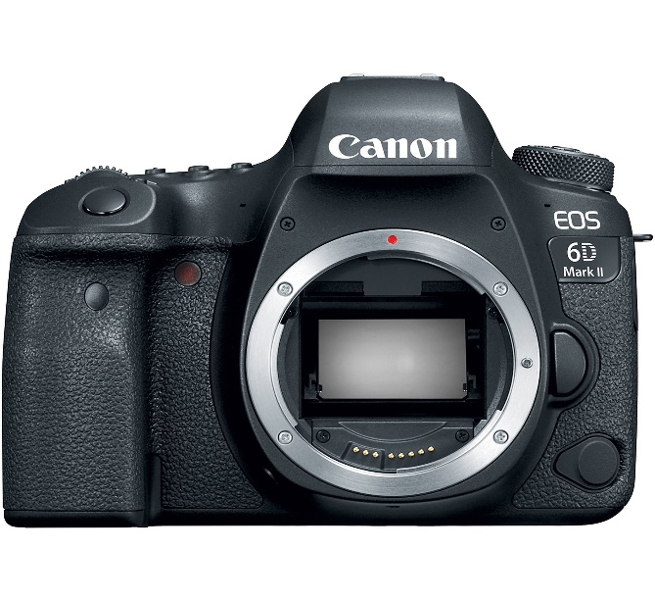

**The Canon EOS 6D Mark II has a 45-point cross-focus system that helps capture the movement of objects smoothly and extremely smoothly, as well as significantly increase image sharpness.**

**The Dual Pixel CMOS AF system helps the camera's focusing performance when recording video or in live view mode much better than its predecessor.**

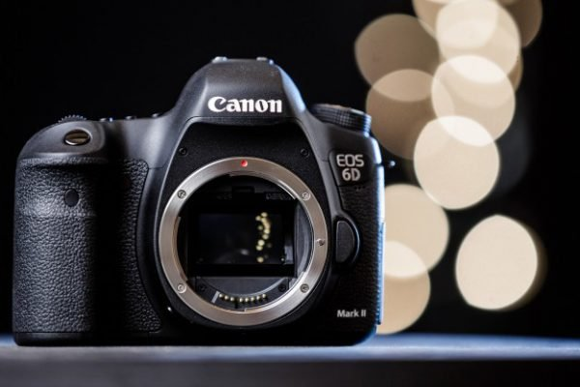

**Canon EOS 6D Mark II can record Full HD resolution videos with frame rates up to 60 fps. The device is also equipped with 5-axis digital anti-shake technology to significantly increase the smoothness of video recording experience.**

**Combined with the 3.5mm microphone jack, it makes recording easier in many different weather conditions.**

**The Canon 6D mark II is equipped with a large capacity battery LP-E6N and can be equipped with a battery grip to help the machine increase its usage time by 300% compared to normal.**

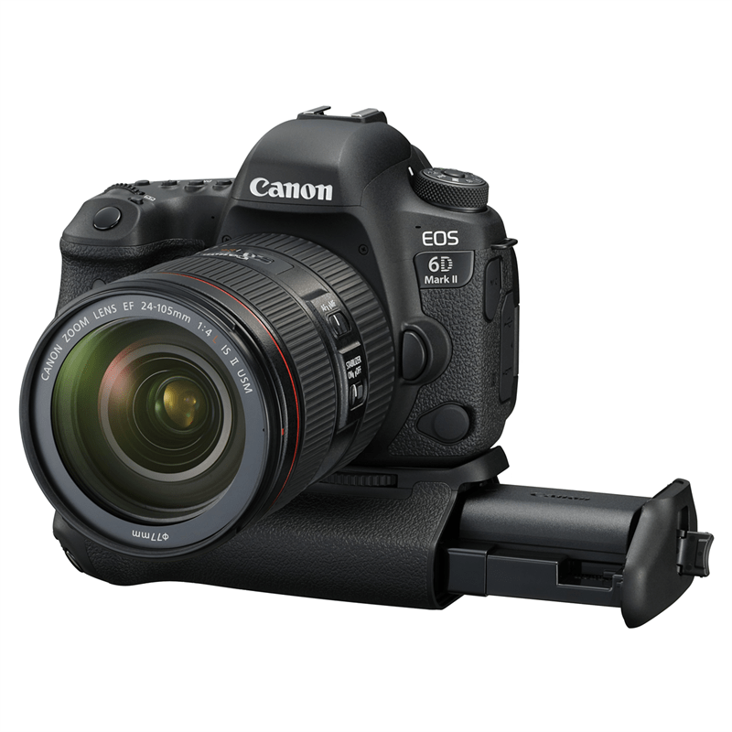

**Along with that is a series of wireless connections that help this Canon camera transfer data extremely quickly and easily.**